Ex. No.: 11

Date:

**DATABASE WITH AUTO_INCREMENT SEQUENCES**

**AIM:**

To create Auto_Incrementsequence on the given relation.

**DESCRIPTION:**

**SEQUENCE:**

In MySQL, a sequence is a **list of integers generated in the ascending order i.e., 1,2,3…** Many applications need sequences to generate unique numbers mainly for identification e.g., customer ID in CRM, employee numbers in HR, equipment numbers in services management system, etc.

To create a sequence in MySQL automatically, you set the AUTO_INCREMENT attribute to a column, which typically is a primary key column.

**SYNTAX:**

**CREATE TABLE** table_name(

col_name1 **AUTO_INCREMENT PRIMARY KEY,** col_name2, col_name3, ….);

**Questions:**

1. Populate register number using auto increment in DBMS_Stud table.
2. Manually populate register number
3. Drop the auto increment.

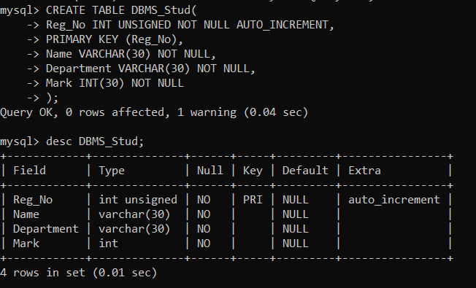

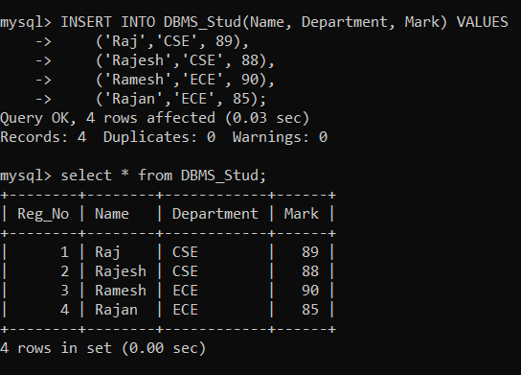

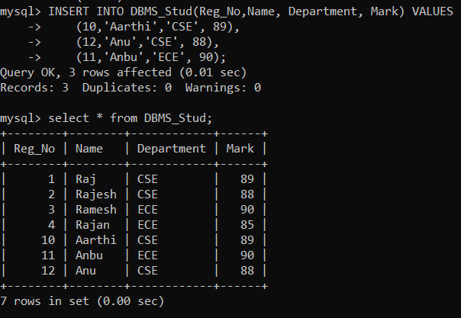

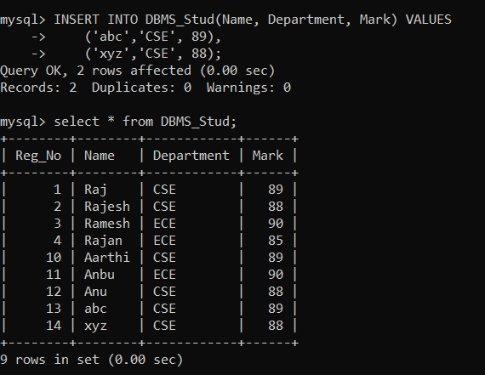

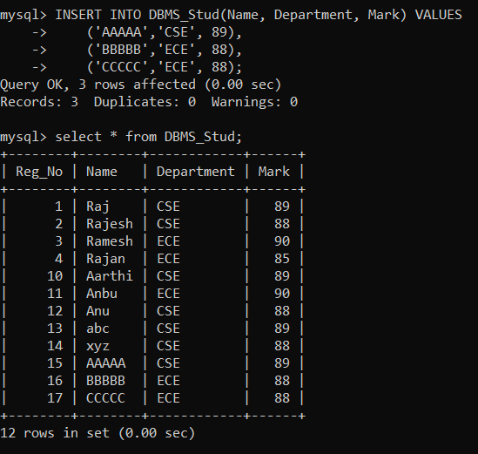

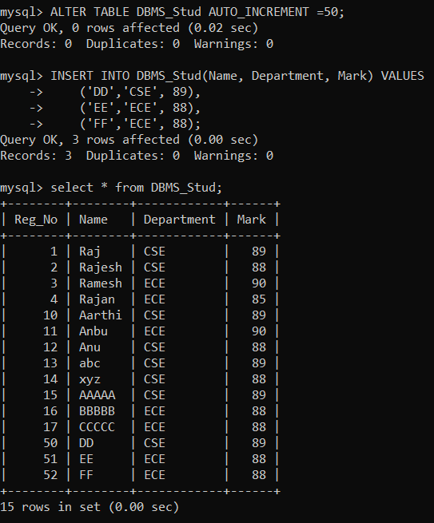

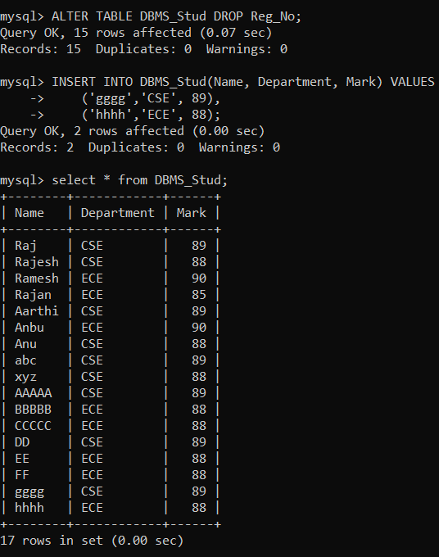

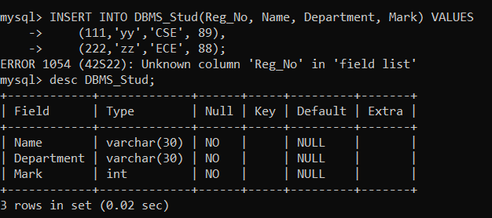

**RESULT**:

The records from the tables are displayed using auto_incrementsequence on the given relation